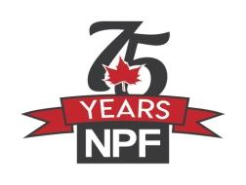

**NATIONAL PENSIONERS FEDERATION 2025 CONVENTION**

**RESOLUTION SUBMISSION TEMPLATE**

**Affiliated Group/Club Name: __________________________________________**

**Individual Member Name: ____________________________________________**

**President:____________________ Recording -Secretary: __________________**

**Topic: NPF Business ( example - Health Care, Finance, Housing etc)**

**Title: New Format for submitting resolutions**

**National Pensioners Federation WILL:** (*formerly- “Therefore be it Resolved”)*

1. Encourage all affiliated groups/clubs/members to use the NEW recommended format for resolutions; and
2. Limit resolutions word format of 150 words or fewer.

**BECAUSE:** *(Formerly- ‘Whereas”)*

* The National Pensioners Federation convention resolution procedure will run smoother when resolutions are succinct, worded and laid out uniform/similar fashion ; and
* The Resolutions Committee is able to identify writers/signatories where such resolution has been approved by the affiliate and its membership; and
* The National Pensioners Federation resolution committee must review, clarify and apply procedure on many resolutions.

**SUBMITTED BY _________________________________**

______________________________________________

**Location/contact**

______________________________________________

**Passed on Date**